FACULTY EVALUATION
Programme Name: Social Entrepreneurship Development Program (SEDP)- Advance Uganda (2nd March 2026 - 6th March 2026)
Session: Funding Sources
Faculty Name: Dr. Tom Buringuriza
No. of Respondents: 16
No. of Participants: 16
Evaluation Parameter | (%) Individual Score | (%) Programme Average
Punctuality (Commencement and Completion of Sessions) | 98 | 91
How well do you understand the core concepts presented? | 90 | 92
Rate your confidence in applying the new skills learnt | 88 | 87
Degree of Faculty preparedness for the sessions | 98 | 97
Content and methodology of the program | 95 | 95
Quality of class and group discussions | 84 | 89
The information presented in the course is relevant to my work (ministry) | 96 | 97
Average scores | 93 | 93

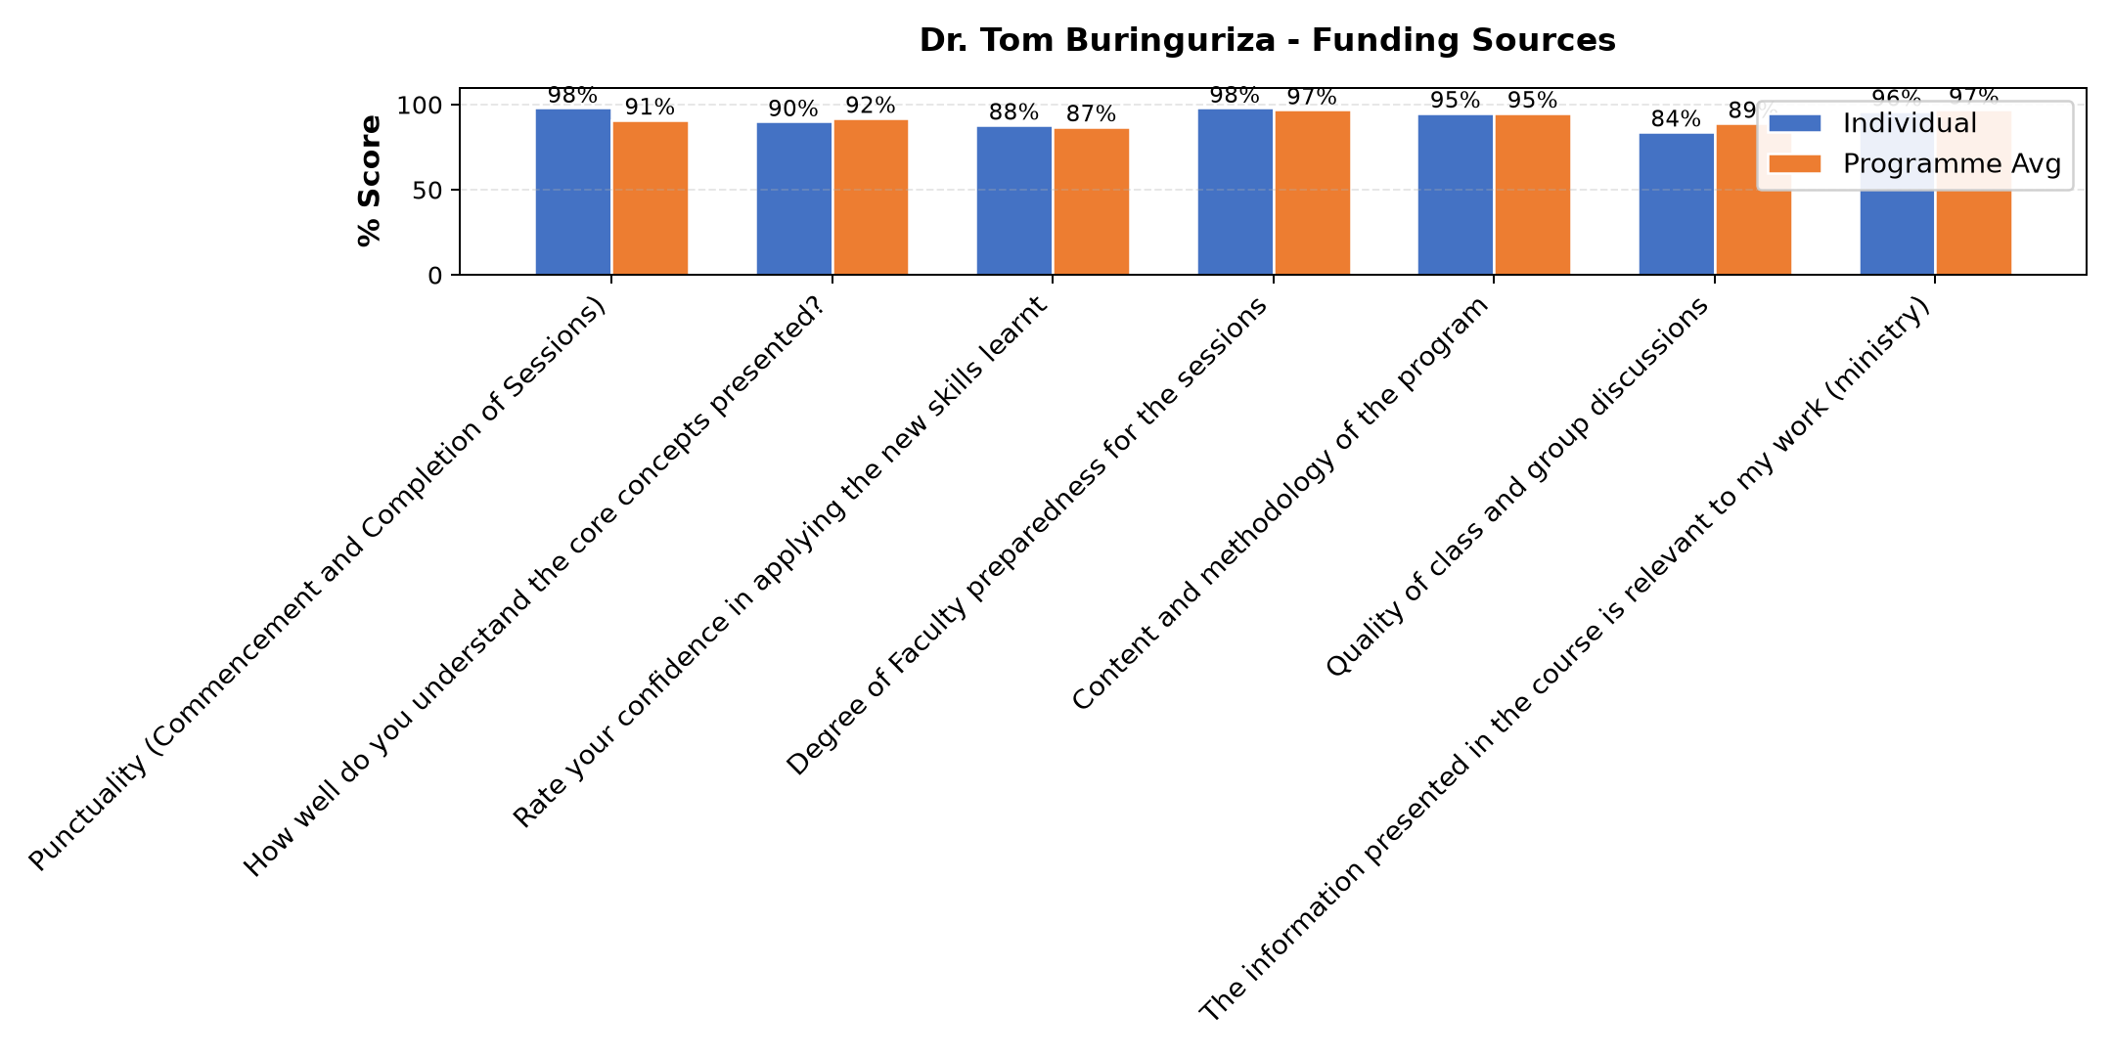

Comments & Feedback
- • Finance
- • Shortage of enough funds
- • Inadequate infrastructure, personal mindset or motivation issues, and external constraints such as policies or financial limitations.
- • Lack of skills. One day is not enough if you have never learnt accountants
- • Commitment $ long distance banking very little money collected.
- • A lot is still needed to learn
- • Finance
- • I personally do not have any barrier in applying what i have learnt; I have to put it into practice immediately and always.
SUBMITTED THROUGH:
SBS Evaluation Automation System

